Naam: ………………………………………….

Datum: ………………………………………..

**Voorbereiding eindtoets 4de leerjaar: wiskunde: cijferen**

**Reken uit. Vergeet niet eerst te schatten.**

**Maak ook de omgekeerde bewerking bij de oefeningen met een *.**

**\* 7406 + 309 = 438 + 2400 + 6342= * 352,453 + 365,1 =**

Ik schat: Ik schat: Ik schat:

7400 + 310= 7710 440 + 2400 + 6340 = 9140 350 + 360 = 710

|  |  |  |  |
| --- | --- | --- | --- |
|  |  | 1 |  |
| 7 | 4 | 0 | 6 |
|  | 3 | 0 | 9 |
| 7 | 7 | 1 | 5 |

|  |  |  |  |
| --- | --- | --- | --- |
| 1 |  | 1 |  |
|  | 4 | 3 | 8 |
| 2 | 4 | 0 | 0 |
| 6 | 3 | 4 | 2 |
| 9 | 1 | 8 | 0 |

|  |  |  |  |  |  |  |
| --- | --- | --- | --- | --- | --- | --- |
|  | 1 |  |  |  |  |  |
|  | 3 | 5 | 2 , | 4 | 5 | 3 |
|  | 3 | 6 | 5 , | 1 | 0 | 0 |
|  | 7 | 1 | 7, | 1 | 5 | 3 |

+

+

|  |  |  |  |  |  |  |
| --- | --- | --- | --- | --- | --- | --- |
|  | 6 | 11 |  |  |  |  |
|  | 7 | 1 | 7 , | 1 | 5 | 3 |
|  | 3 | 6 | 5, | 1 | 0 | 0 |
|  | 3 | 5 | 2 , | 0 | 5 | 3 |

|  |  |  |  |
| --- | --- | --- | --- |
|  |  | 0 | 15 |
| 7 | 7 | 1 | 5 |
|  | 3 | 0 | 9 |
| 7 | 4 | 0 | 6 |

-

-

Mijn schatting is: Mijn schatting is: Mijn schatting is:

O goed O goed O goed

O niet goed O niet goed O niet goed

**427 x 8 = 3305 x 30 =**

Ik schat: 400 x 8 = 3200 Ik schat: 3300 x 30 = 99 000

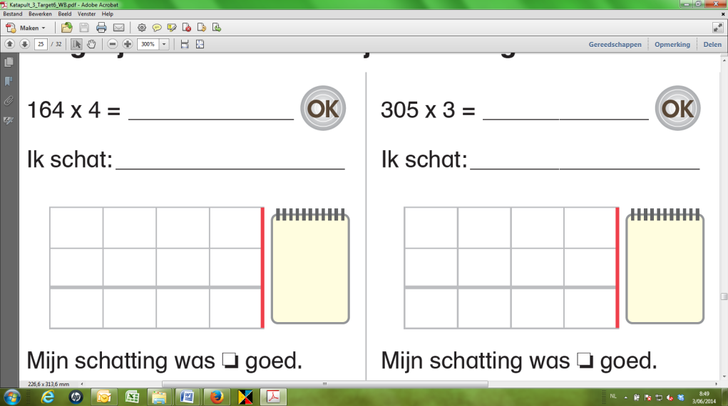****

|  |  |  |  |  |  |  |  |  |  |
| --- | --- | --- | --- | --- | --- | --- | --- | --- | --- |
|  |  |  |  | +  x |  |  |  |  |  |
| x | 4 | 2 | 7 |  | 3 | 3 | 0 | 5 |
|  |  |  | 8 |  |  |  | 3 | 0 |
| 3 | 4 | 1 | 6 |  | 0 | 0 | 0 | 0 |
|  |  |  |  | 9 | 9 | 1 | 5 | 0 |
|  |  |  |  | 9 | 9 | 1 | 5 | 0 |

Mijn schatting is: Mijn schatting is:

O goed O goed

O niet goed O niet goed

**\* 3668 - 354 = * 7603 - 1572= * 748 - 29,251=**

Ik schat: Ik schat: Ik schat:

3670 – 350= 3320 7600 – 1570 = 6030 750 – 30 = 720

|  |  |  |  |
| --- | --- | --- | --- |
|  |  |  |  |
| 3 | 6 | 6 | 8 |
|  | 3 | 5 | 4 |
| 3 | 3 | 1 | 4 |

|  |  |  |  |
| --- | --- | --- | --- |
|  | 5 | 10 |  |
| 7 | 6 | 0 | 3 |
| 1 | 5 | 7 | 2 |
| 6 | 0 | 3 | 1 |

|  |  |  |  |  |  |
| --- | --- | --- | --- | --- | --- |
|  | 3 | 17 | 9 | 9 | 10 |
| 7 | 4 | 8, | 0 | 0 | 0 |
|  | 2 | 9, | 2 | 5 | 1 |
| 7 | 1 | 8, | 7 | 4 | 9 |

-

-

-

|  |  |  |  |
| --- | --- | --- | --- |
|  |  |  |  |
| 3 | 3 | 1 | 4 |
|  | 3 | 5 | 4 |
| 3 | 6 | 6 | 8 |

|  |  |  |  |
| --- | --- | --- | --- |
|  |  |  |  |
| 6 | 0 | 3 | 1 |
| 1 | 5 | 7 | 2 |
| 7 | 6 | 0 | 3 |

|  |  |  |  |  |  |
| --- | --- | --- | --- | --- | --- |
|  |  |  |  |  |  |
| 7 | 1 | 8, | 7 | 4 | 9 |
|  | 2 | 9, | 2 | 5 | 1 |
| 7 | 4 | 8, | 0 | 0 | 0 |

+

+

+

Mijn schatting is: Mijn schatting is: Mijn schatting is:

O goed O goed O goed

O niet goed O niet goed O niet goed

**7911 : 7 = 33145 : 3 =**

Ik schat: Ik schat:

7700 : 7 = 1100 33000 : 3= 11000

|  |  |  |  |  |  |  |  |  |  |  |  |  |  |  |  |  |  |  |
| --- | --- | --- | --- | --- | --- | --- | --- | --- | --- | --- | --- | --- | --- | --- | --- | --- | --- | --- |
| **7** | **9** | **1** | **1** | **7** |  |  |  |  | **3** | **3** | **1** | **4** | **5** | **3** |  |  |  |  |
| 7 |  |  |  | 1 | 1 | 3 | 0 | 3 |  |  |  |  | 1 | 1 | 0 | 4 | 8 |
| 0 | 9 |  |  |  |  |  |  | 0 | 3 |  |  |  |  |  |  |  |  |
|  | 7 |  |  |  |  |  |  |  | 3 |  |  |  |  |  |  |  |  |
|  | 2 | 1 |  |  |  |  |  |  | 0 | 1 |  |  |  |  |  |  |  |
|  | 2 | 1 |  |  |  |  |  |  |  | 0 |  |  |  |  |  |  |  |
|  |  | 0 | 1 |  |  |  |  |  |  | 1 | 4 |  |  |  |  |  |  |
|  |  |  |  |  |  |  |  |  |  | 1 | 2 |  |  |  |  |  |  |
|  |  |  |  |  |  |  |  |  |  |  | 2 | 5 |  |  |  |  | http://i10.ebayimg.com/02/i/001/21/2b/66a3_35.JPG |
|  |  |  |  |  |  |  |  |  |  |  | 2 | 4 |  |  |  |  |  |
|  |  |  |  |  |  |  |  |  |  |  |  | 1 |  |  |  |  |  |

Waarde van de rest: 1 Waarde van de rest: 1………………..

Mijn schatting is: Mijn schatting is:

O goed O goed

**Veel succes!**

O minder goed O minder goed